# IT666 – Cloud Security Lab

Ryan J. Skelly – [rjs1070@wildcats.unh.edu](mailto:rjs1070@wildcats.unh.edu) – 4/7/21

**Lab report:**

Task 2: (50 points) Provide screenshot of your completed training and email confirmation. 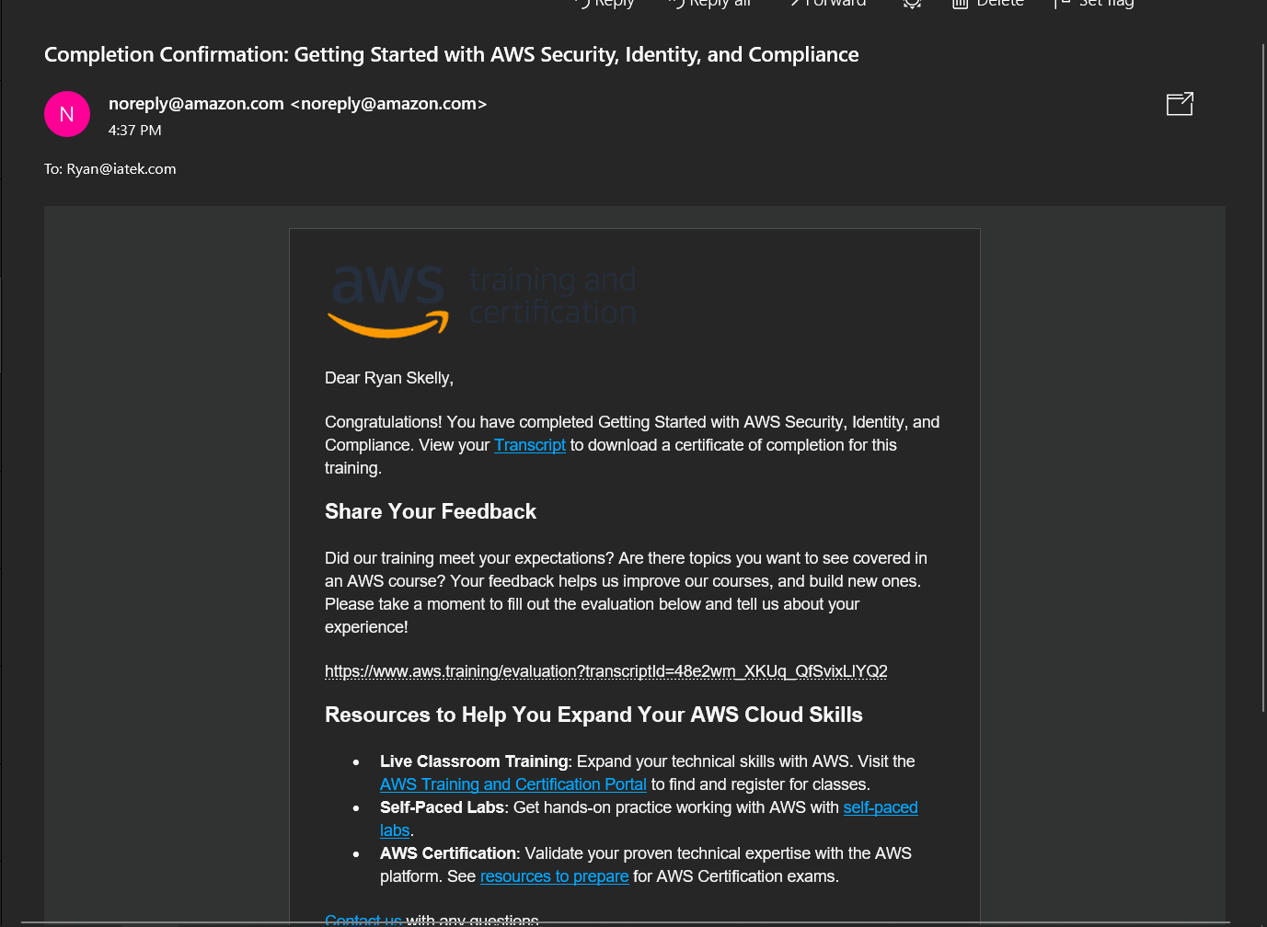

Task 3: (50 points) Provide screenshot of your completed training and email confirmation. 